Our Esteemed Clients

- PharmaHealth Pakistan ( Pvt. Ltd )
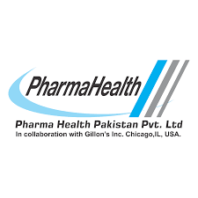

- Unilever Pakistan ( Pvt. Ltd )
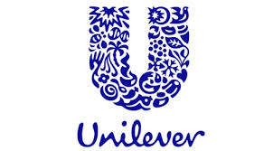
- L’Oreal Pakistan ( Pvt. Ltd )
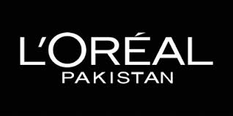
- Derresthetic International ( Pvt. Ltd )
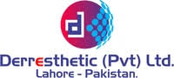
- ICI Pakistan ( Pvt. Ltd ) 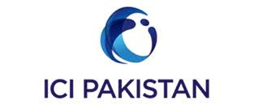
- Brand Smith Pakistan ( Pvt. Ltd ) 